Fusion

**Extro Two-Way Bib Cock with Swivel Spout – Sink Mixer**

**📝 Product Description:**

A versatile and elegantly designed two-handle sink mixer with a high-arc swivel spout, perfect for kitchen or basin use where dual water temperature control is required.

**⭐ 5 Key Features (Single Line Each):**

* Dual-handle control for hot and cold water mixing
* 360° swivel spout for easy sink accessibility
* Mirror chrome finish enhances durability and aesthetics
* Anti-drip brass cartridge ensures smooth operation
* Suitable for wall-mounted kitchen or washbasin sinks

**📐 Product Specifications:**

* **Body Material:** Heavy-duty brass
* **Finish:** Chrome plated
* **Handle Type:** Dual lever knobs
* **Spout Type:** High-arc rotating swivel
* **Mount Type:** Wall mount
* **Cartridge:** Quarter-turn ceramic disc
* **Application:** Kitchen/basin mixer
* **Flow Type:** Normal foam flow

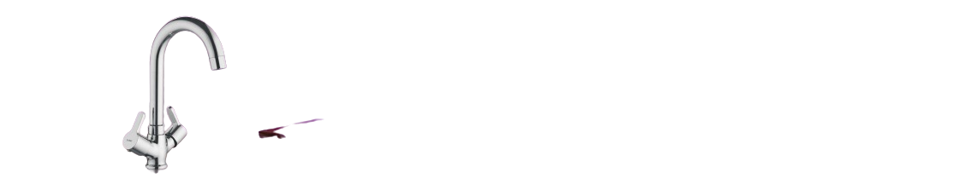

**Extro Fusion Bib Cock – Quarter Turn Faucet**

**📝 Product Description:**

The Fusion Bib Cock offers a sleek, modern design with a single-lever control, providing effortless water flow and shut-off. Its compact form is ideal for washbasins, utility areas, or general-purpose water outlets.

**⭐ 5 Key Features (Single Line Each):**

* Single-lever control for smooth one-hand operation
* Chrome-plated finish resists corrosion and tarnishing
* Wall-mounted design with compact aesthetic appeal
* Fitted with ceramic disc cartridge for long-lasting use
* Ideal for residential, bathroom, or commercial spaces

**📐 Product Specifications:**

* **Material:** Pure brass construction
* **Finish:** Premium chrome plating
* **Mount Type:** Wall mount
* **Operation:** Quarter turn single lever
* **Cartridge Type:** Ceramic disc
* **Flow Type:** Normal foam flow
* **Application:** Washbasin, utility tap, or garden connection
* **Thread Size:** Standard 15mm (½ inch BSP)

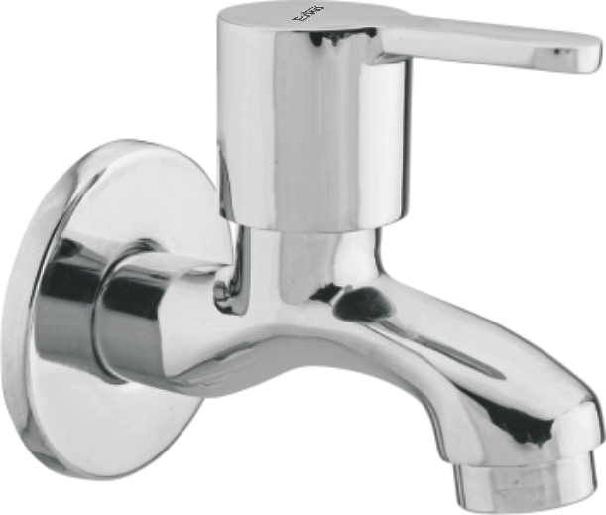

**Extro Fusion Bib Cock – Long Body**

**📝 Product Description:**

The Fusion Long Body Bib Cock is a wall-mounted faucet designed for enhanced reach and convenience, featuring a single-lever control and robust brass body ideal for washbasins and utility areas.

**⭐ 5 Key Features (Single Line Each):**

* Long-body design for extended reach and improved usability
* Smooth single-lever operation for effortless flow control
* Rust-resistant chrome finish ensures lasting shine
* Ceramic disc cartridge delivers drip-free performance
* Durable brass construction ensures long life and reliability

**📐 Product Specifications:**

* **Material:** Heavy-duty brass
* **Finish:** Mirror-finish chrome plating
* **Mount Type:** Wall mounted
* **Design:** Long body bib cock
* **Operation:** Quarter-turn single lever
* **Flow Type:** Normal aerated flow
* **Cartridge:** Ceramic disc cartridge
* **Inlet Size:** 15mm (½ inch BSP) standard

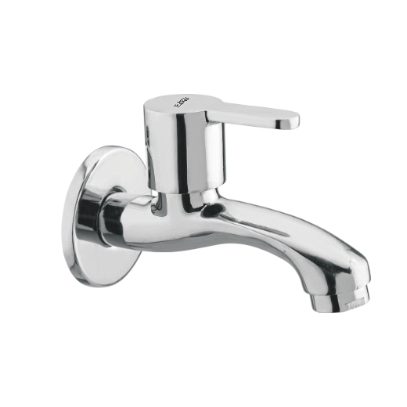

**Extro Fusion Angular Stop Cock**

**📝 Product Description:**

The Fusion Angular Stop Cock is a precision-engineered valve designed for efficient water control in bathrooms and kitchens, ideal for connecting to health faucets, cisterns, or washing machines.

**⭐ 5 Key Features (Single Line Each):**

* Sleek lever handle for smooth and precise control
* Angular design for compact wall installation
* High-quality brass body for enhanced durability
* Chrome-plated finish resists tarnishing and corrosion
* Compatible with standard plumbing fittings (1/2” BSP)

**📐 Product Specifications:**

* **Material:** Solid brass
* **Finish:** Chrome-plated, mirror finish
* **Installation Type:** Wall-mounted
* **Connection Size:** 15mm (½ inch BSP male thread outlet)
* **Control Type:** Quarter-turn lever handle
* **Flow Type:** Controlled stop-valve flow
* **Application:** Ideal for geysers, flush tanks, and washing appliances
* **Cartridge:** Ceramic disc for leak-proof operation

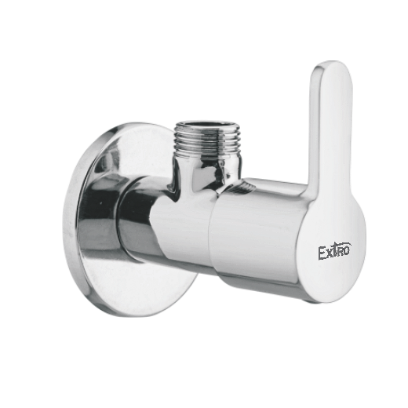

**Extro Fusion Concealed Stop Cock**

**📝 Product Description:**

The Fusion Concealed Stop Cock offers reliable water flow control with a stylish handle and robust brass body, ideally suited for concealed plumbing installations in modern bathrooms and kitchens.

**⭐ 5 Key Features (Single Line Each):**

* Concealed installation offers a clean and elegant look
* High-quality brass body ensures long-term durability
* Ergonomic lever handle for smooth operation
* Chrome finish resists rust, tarnish, and scratches
* Suitable for high and low water pressure systems

**📐 Product Specifications:**

* **Material:** Solid brass body with chrome-plated handle
* **Finish:** Polished chrome for a glossy appearance
* **Installation Type:** Concealed in-wall mounting
* **Connection Size:** 15mm (½ inch BSP)
* **Operation Type:** Quarter-turn lever with ceramic disc
* **Application:** Ideal for showers, basins, and flush connections
* **Cartridge Type:** Ceramic disc for drip-free performance
* **Flow Direction:** Uni-directional with flow arrow engraving

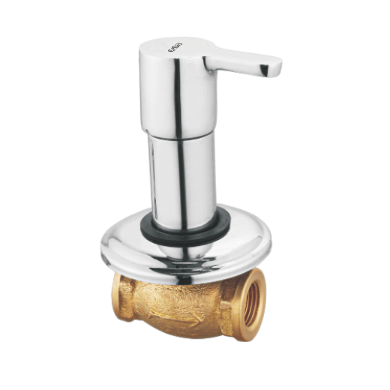

**Extro Fusion Pillar Cock**

**📝 Product Description:**

The Fusion Pillar Cock features a compact, modern design with a smooth handle and a highly reflective chrome finish, making it ideal for installation on wash basins in homes, offices, and commercial spaces.

**⭐ 5 Key Features (Single Line Each):**

* Modern cylindrical design with ergonomic lever
* Corrosion-resistant chrome-plated brass body
* Single-lever operation for effortless control
* Suitable for countertop basin installations
* Smooth water flow with splash-free aerator

**📐 Product Specifications:**

* **Material:** Brass body with chrome plating
* **Mounting Type:** Pillar/Deck mounted
* **Finish:** Glossy chrome
* **Operation:** Single lever with ceramic disc cartridge
* **Connection Size:** Standard ½ inch inlet
* **Height:** Medium-rise for optimal basin clearance
* **Application:** Ideal for wash basins or sinks
* **Flow Type:** Aerated stream for smooth water delivery

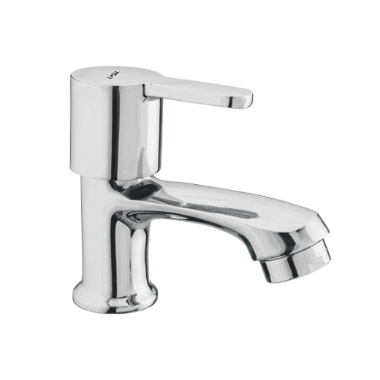

**Extro Fusion Wall Mixer**

**📝 Product Description:**

The Extro Fusion Wall Mixer combines sleek aesthetics with dual-functionality, offering effortless mixing of hot and cold water along with a diverter option—perfect for modern bathrooms with overhead and hand showers.

**⭐ 5 Key Features (Single Line Each):**

* Dual-function wall mixer with diverter control
* Smooth single-lever operation for temperature control
* Sturdy brass construction with premium chrome finish
* Compatible with overhead and hand shower outlets
* Splash-free water flow with inbuilt aerator system

**📐 Product Specifications:**

* **Material:** Brass with chrome plating
* **Mounting Type:** Wall-mounted
* **Finish:** Mirror-polished chrome
* **Operation:** Single lever + diverter knob
* **Inlet/Outlet Size:** Standard ¾ inch & ½ inch
* **Application:** Bathtub and shower mixer
* **Functionality:** Hot/Cold mixing + shower/bath diverter
* **Cartridge Type:** Ceramic disc for long life

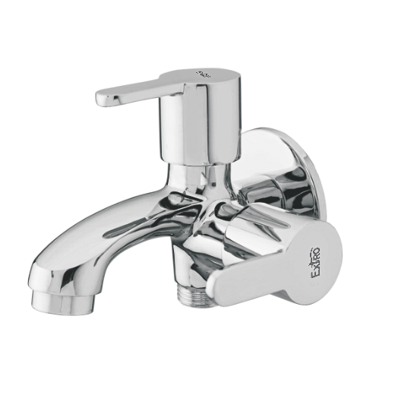

**Extro Fusion Angle Valve with Dual Outlet**

**📝 Product Description:**

The Extro Fusion Angle Valve with Dual Outlet is designed to offer precise control and dual water outlet functionality, making it ideal for modern bathrooms or kitchens requiring separate connections for a geyser, hand shower, or health faucet.

**⭐ 5 Key Features (Single Line Each):**

* Dual outlet control for geyser and hand shower or health faucet
* Sleek modern design with single lever control
* Corrosion-resistant high-grade chrome finish
* Leak-proof ceramic disc cartridge
* Wall flange included for easy installation

**📐 Product Specifications:**

* **Material:** Brass body with chrome plating
* **Mounting Type:** Wall-mounted
* **Finish:** Glossy chrome
* **Operation:** Single lever + additional knob for outlet control
* **Inlet Size:** ½ inch BSP standard
* **Outlet Ports:** Dual – ½ inch (top and bottom)
* **Functionality:** Angle valve + 2-way diverter
* **Usage:** Ideal for geyser, bidet spray, or secondary tap connection

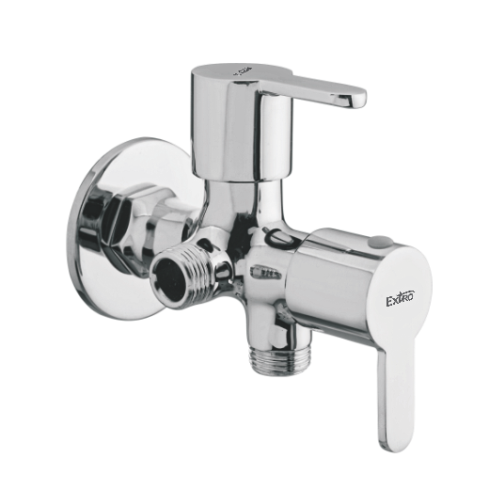

**Extro Fusion Wall Mounted Sink Cock with Swivel Spout**

**📝 Product Description:**

The Extro Fusion Wall Mounted Sink Cock features a tall, curved swivel spout ideal for kitchen and utility sinks, combining functionality with a contemporary, streamlined design.

**⭐ 5 Key Features (Single Line Each):**

* Tall swivel spout for wider sink coverage
* Wall-mounted for better space utilization
* Smooth quarter-turn lever handle for effortless control
* Rust and corrosion-resistant chrome finish
* Easy to install and compatible with standard plumbing

**📐 Product Specifications:**

* **Material:** Brass body with high-grade chrome plating
* **Mounting Type:** Wall-mounted
* **Spout Type:** Swivel casted spout (Gooseneck)
* **Finish:** Glossy chrome
* **Handle Type:** Single lever
* **Inlet Connection Size:** ½ inch BSP
* **Application:** Kitchen sink, utility sink, wall-mounted basins
* **Flow Type:** Normal water stream with aerator

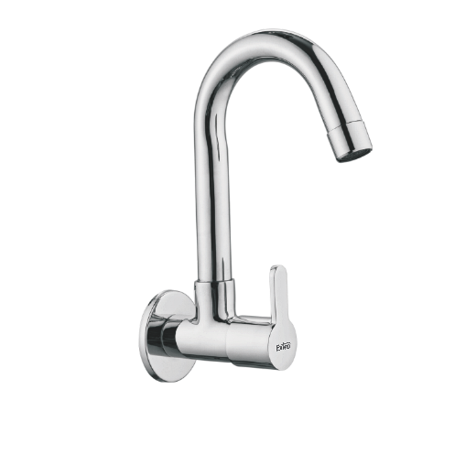

**Extro Fusion Table Mounted Sink Cock with Swivel Spout**

**📝 Product Description:**

The Extro Fusion Table Mounted Sink Cock is designed with a high-arc swivel spout, offering elegant form and practical function for kitchens and counters with top-mounted installations.

**⭐ 5 Key Features (Single Line Each):**

* 360° swivel spout for full sink access
* Table-mounted design ensures easy countertop installation
* Durable brass construction with high-gloss chrome finish
* Smooth single lever for effortless water flow and temperature control
* Modern minimalist aesthetics suitable for contemporary kitchens

**📐 Product Specifications:**

* **Material:** Brass with chrome plating
* **Mounting Type:** Table-mounted (deck-mounted)
* **Spout Type:** High-rise gooseneck swivel spout
* **Finish:** Polished chrome
* **Handle Type:** Single lever
* **Inlet Connection Size:** ½ inch BSP
* **Application:** Kitchen sink, countertop installations
* **Flow Type:** Normal aerated stream

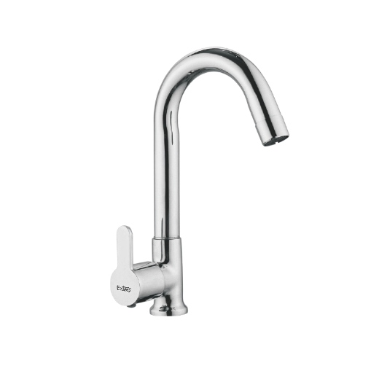

**Extro Fusion Wall Mounted Sink Mixer with Swivel Spout**

**📝 Product Description:**

The Extro Fusion Wall Mounted Sink Mixer blends form and function with a dual-handle design and a high-rise swivel spout, perfect for stylish and efficient kitchens or utility areas.

**⭐ 5 Key Features (Single Line Each):**

* Wall-mounted design ideal for saving counter space
* High-arc 360° swivel spout provides full sink coverage
* Dual lever handles for separate hot and cold control
* Sleek chrome-plated brass body for durability and shine
* Ergonomic design for modern modular kitchens

**📐 Product Specifications:**

* **Material:** Brass with chrome finish
* **Mounting Type:** Wall-mounted
* **Spout Type:** Swivel spout with gooseneck arc
* **Finish:** Mirror-like chrome plating
* **Handle Type:** Dual lever (hot & cold)
* **Inlet Connection Size:** ¾ inch standard wall inlet
* **Flow Type:** Aerated flow for splash-free operation
* **Application:** Kitchen sinks, utility sinks, wash areas

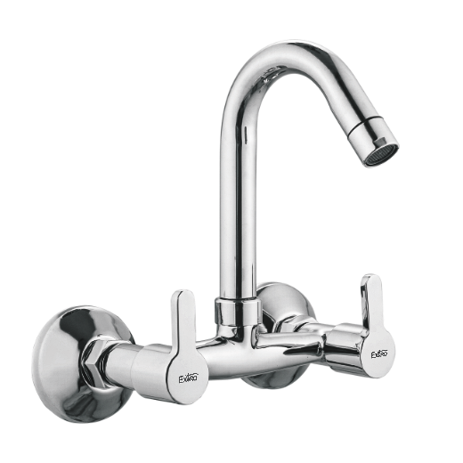

**Extro Fusion Table Mounted Sink Mixer with Swivel Spout**

**📝 Product Description:**

The Extro Fusion Table Mounted Sink Mixer combines a stylish curved spout with ergonomic dual handles, offering precise control over hot and cold water flow for contemporary kitchen or basin setups.

**⭐ 5 Key Features (Single Line Each):**

* Elegant table-mounted design perfect for countertops
* 360° swivel spout for full sink accessibility
* Dual lever handles for independent temperature control
* Chrome-finished brass body for corrosion resistance and shine
* Smooth flow technology for splash-free operation

**📐 Product Specifications:**

* **Material:** Heavy-duty brass with chrome plating
* **Mounting Type:** Table-mounted
* **Spout Type:** Swivel gooseneck
* **Finish:** Mirror chrome
* **Handle Type:** Dual lever (hot & cold)
* **Installation Hole Size:** Standard deck hole fitting
* **Inlet Type:** Dual inlet for hot and cold supply
* **Ideal Use:** Kitchen sinks, table-top basins

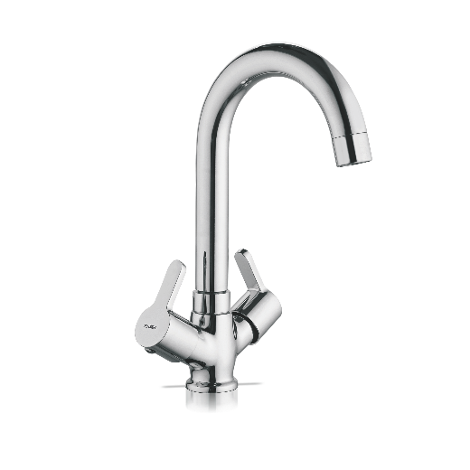

**Extro Fusion Wall Mixer with L-Bend for Overhead Shower**

**📝 Product Description:**

The Extro Fusion Wall Mixer with L-Bend offers a refined dual-flow system that integrates a spout and overhead shower outlet, perfect for modern bathrooms needing stylish functionality and water direction control.

**⭐ 5 Key Features (Single Line Each):**

* Dual-function outlet with spout and overhead shower connection
* Smooth-operating quarter-turn handles for hot and cold water control
* L-bend design directs water to overhead shower efficiently
* Corrosion-resistant chrome-plated brass body
* Easy wall-mounted installation with standard fittings

**📐 Product Specifications:**

* **Material:** Brass with premium chrome finish
* **Mounting Type:** Wall-mounted
* **Handle Type:** Dual lever with center diverter knob
* **Outlets:** Spout + Overhead Shower Pipe (L-bend)
* **Finish:** Polished chrome
* **Inlet Connection Size:** Standard 15mm BSP
* **Control Type:** Manual hot & cold water mixing
* **Ideal Use:** Bathrooms (bathtub + shower combo setups)

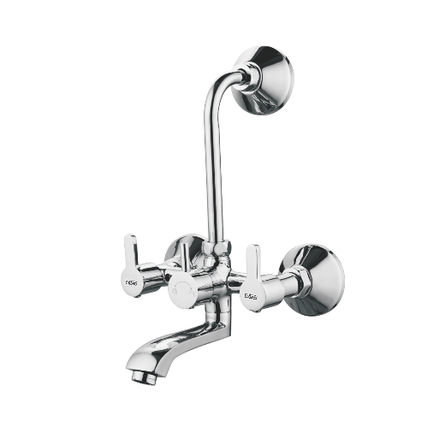

**Extro Fusion Wall Mixer with L-Bend and Overhead Shower Provision**

**📝 Product Description:**

The Extro Fusion Wall Mixer with L-Bend is a contemporary 3-in-1 bathing solution that enables precise water mixing and seamless switching between overhead shower and tub spout, making it ideal for modern bathrooms seeking a minimalistic yet versatile fixture.

**⭐ 5 Key Features (Single Line Each):**

* Integrated diverter controls flow between tub spout and overhead shower
* Premium brass construction with mirror-like chrome finish
* Smooth dual lever operation for hot and cold water mixing
* Ergonomic wall-mounted design with included L-bend pipe
* Corrosion-resistant and long-lasting performance in all water conditions

**📐 Product Specifications:**

* **Material:** Solid brass with high-quality chrome plating
* **Mounting Type:** Wall-mounted
* **Flow Type:** Manual diverter system (Spout & Overhead Shower)
* **Handle Type:** Two lever handles with diverter knob
* **Finish:** Glossy chrome
* **Inlet Size:** 15mm BSP standard
* **Recommended Use:** Bathtub and overhead shower combination setups
* **Accessories Included:** L-bend pipe for overhead shower

